Problem 1 : find the count of all String with length 4

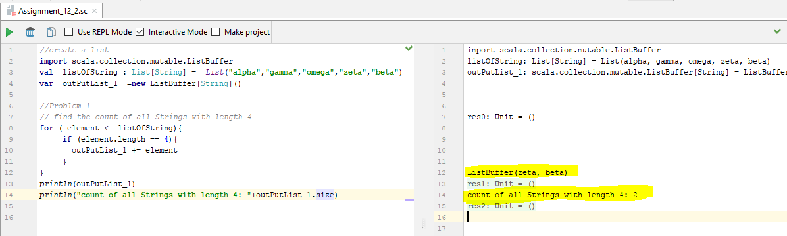

Problem 2 :

*//convert the list of string to a list of integers,  
// where each string is mapped to its corresponding length*

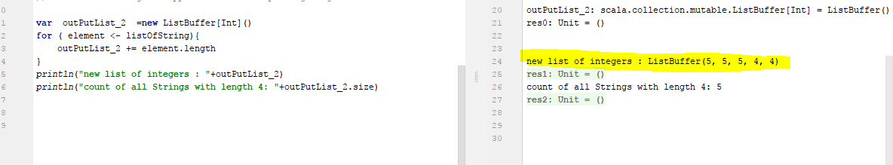

Problem 3

*//Problem 3  
//find count of all strings which contain alphabet ‘m’*

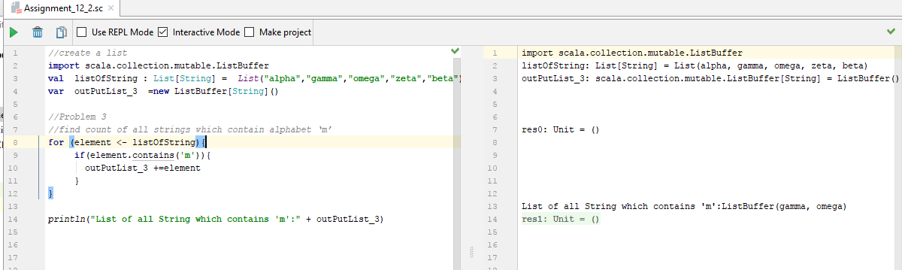

*//Problem 4  
//find the count of all strings which start with the alphabet ‘a’*

